# **Practical – 1**

**Aim :**

1. Write a JS arrow function to find missing number in an Array.
2. Write a JS arrow function to find second largest and second smallest number from given array.
3. **Code:**

<!DOCTYPE html>

<html lang="en">

<head>

<meta charset="UTF-8">

<meta name="viewport" content="width=device-width, initial-scale=1.0">

<title>Document</title>

</head>

<body>

<script>

var arr = [1, 2, 4, 5, 6, 8, 10];

const findMissingElement = (array) => {

for (let i = 0; i < array.length; i++) {

if (array[i] !== i + 1) {

return i + 1;

}

}

return null;

};

console.log(arr);

console.log(findMissingElement(arr));

</script>

</body>

</html>

**Output:**

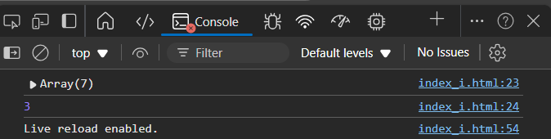  
***Figure I:*** *Missing number in Array*

1. **Code:**

<!DOCTYPE html>

<html lang="en">

<head>

    <meta charset="UTF-8">

    <meta name="viewport" content="width=device-width, initial-scale=1.0">

    <title>Document</title>

</head>

<body>

    <script>

        var sort = (arr) => {

            for (var i = 0; i < arr.length; i++) {

                var min = i;

                for (var j = i + 1; j < arr.length; j++) {

                    if (arr[j] < arr[min]) {

                        min = j;

                    }

                }

                if (arr[min] < arr[i]) {

                    var temp = arr[min];

                    arr[min] = arr[i];

                    arr[i] = temp;

                }

            }

        };

        var array = [10, 8, 3, 6, 5, 1, 2];

        console.log(`Unsorted Array: ${array}`);

        sort(array);

        console.log(`Sorted Array: ${array}`);

        if (array.length >= 2) {

            console.log(`2nd Smallest Element: ${array[1]}`);

            console.log(`2nd Largest Element: ${array[array.length - 2]}`);

        } else {

            console.log("Array does not have enough elements to determine the 2nd smallest and 2nd largest.");

        }

    </script>

</body>

</html>

**Output:**

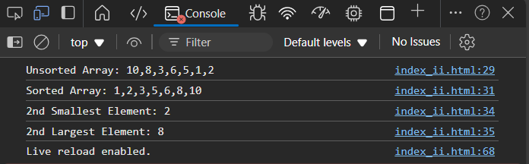  
***Figure II:*** *Second largest and second smallest number from given array.*

# **Practical – 2**

**Aim :** Build a “Guess the Number Game” using JavaScript.

**Code:**

**Index.html**

<!DOCTYPE html>

<html lang="en">

<head>

    <meta charset="UTF-8">

    <meta name="viewport" content="width=device-width, initial-scale=1.0">

    <title>Number guessing</title>

    <style>

        * {

            margin: 0;

            padding: 0;

            box-sizing: border-box;

        }

        .container {

            border: 1px solid black;

            height: 400px;

            width: 400px;

            text-align: center;

            padding-top: 50px;

        }

        input {

            width: 200px;

            height: 50px;

            margin: 10px 0;

        }

        button {

            margin: 10px;

        }

        .msg {

            margin-top: 20px;

            font-size: 18px;

            color: red;

        }

    </style>

</head>

<body>

    <div class="container">

        <div class="input">

            <input type="number" id="guessInput" placeholder="Enter a number">

        </div>

        <div class="btn">

            <button onclick="submit()">Submit</button>

            <button onclick="start()">Start</button>

            <button onclick="again()">Play Again</button>

        </div>

        <div class="msg">

            <p id="msg"></p>

        </div>

    </div>

    <script>

        // Initialize tries and the secret number

        let tries = 5;

        let secretNumber;

        let gameStarted = false;

        let msg = document.getElementById("msg");

        // Function to generate random number between 1 and 100

        const gen = () => {

            return Math.floor(Math.random() * 100) + 1;

        };

        // Function to reset the game

        const again = () => {

            tries = 5;

            gameStarted = false;

            msg.innerHTML = "Game reset. Please click 'Start' to begin.";

            document.getElementById("guessInput").value = "";  // Clear the input field

            document.getElementById("guessInput").disabled = false;  // Re-enable the input field

            document.querySelector("button:nth-child(2)").innerHTML = "Start";  // Change button text to "Start"

        };

        // Function to start the game

        const start = () => {

            let button = document.querySelector("button:nth-child(2)"); // "Start" button

            if (!gameStarted) {

                secretNumber = gen();

                gameStarted = true;

                tries = 5;

                button.innerHTML = "Stop";

                msg.innerHTML = `Game Started! You have ${tries} tries.`;

            } else {

                gameStarted = false;

                button.innerHTML = "Start";

                msg.innerHTML = "Game over!";

                document.getElementById("guessInput").disabled = true;

            }

        };

        // Function to handle submit guess

        const submit = () => {

            if (!gameStarted) {

                msg.innerHTML = "Please start the game first!";

                return;

            }

            let guess = parseInt(document.getElementById("guessInput").value);

            if (isNaN(guess)) {

                msg.innerHTML = "Please enter a valid number.";

                return;

            }

            // Check if guess is correct

            if (guess === secretNumber) {

                msg.innerHTML = `Congratulations! You guessed the number ${secretNumber} correctly!`;

                document.getElementById("guessInput").disabled = true;

            } else {

                tries--;

                if (guess < secretNumber) {

                    msg.innerHTML = `Incorrect! Guess higher. You have ${tries} tries left.`;

                } else if (guess > secretNumber) {

                    msg.innerHTML = `Incorrect! Guess lower. You have ${tries} tries left.`;

                }

                if (tries <= 0) {

                    msg.innerHTML = `Game over! The correct number was ${secretNumber}.`;

                    document.getElementById("guessInput").disabled = true;

                }

            }

            document.getElementById("guessInput").value = "";

        };

    </script>

</body>

</html>

**Fig 2.1 : normal setup**

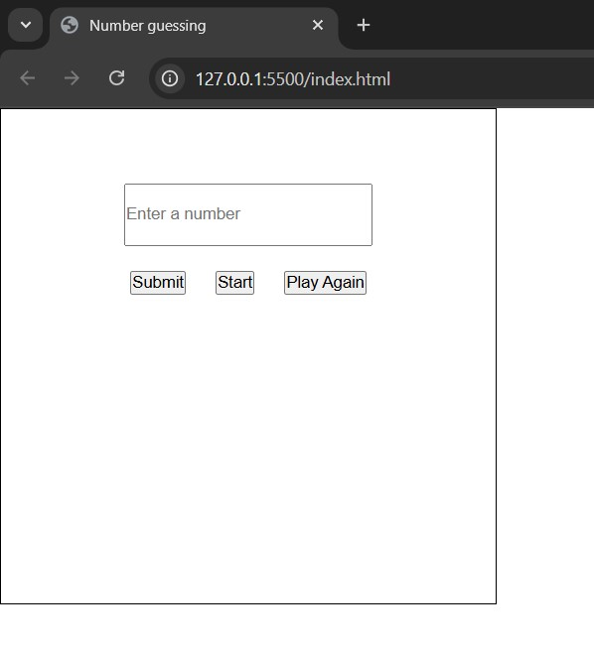

**fig 2.2 : starting the game**

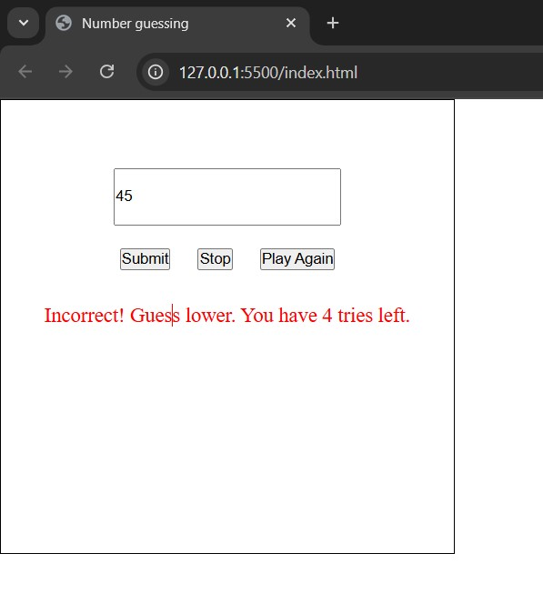

**Fig 2.3 : after finishing the game**

